BrandGuard AI
An Evidence-Based Intelligent Brand Governance and Content Review Platform
Round 1: The Plan
Problem statement: Inkloom AI, Intelligent Brand Governance Platform

Team
Sagar Kharbikar
Ayush Roy

Status of this document
This is a planning proposal. No product code has been written for it. No interviews or experiments have been run, and no performance results are reported. The architecture, workflows and examples describe what we propose to build in the official six-hour build window.

Contents
1. Executive Summary 3
2. Problem Definition and Evidence 4
3. Target Users and Organisational Context 6
4. Research and Validation Plan 8
5. Proposed Solution and Value Proposition 10
6. End-to-End Product Workflow 12
7. Feature Prioritisation and Product Scope 14
8. Technical Architecture and Technology Stack 15
9. Compliance Engine and AI Methodology 17
10. Data Sources, Integrations and Dependencies 19
11. Responsible Design, Privacy and Security 21
12. Six-Hour Development Plan and Team Allocation 23
13. Testing and Evaluation Plan 25
14. Expected Impact and Success Criteria 26
15. Limitations, Risks and Future Roadmap 27
16. Conclusion 28
References 29
Appendix A. Sample Data Schema and API Contract 31
Appendix B. Sample Brand Rules and Sample Audit Response 32
Appendix C. Interview Questionnaire 33
Appendix D. Feature Prioritisation Matrix 34
Appendix E. Risk Register 35
Appendix F. Alignment with Round 1 Requirements and Judging Criteria 36
Tools and AI disclosure 37

1. Executive Summary
Growing organisations publish through employees, agencies and AI writing tools at the same time. The Inkloom AI problem statement describes what can go wrong. Incorrect claims, outdated information, inconsistent language and off-brand visuals can damage credibility before anyone notices [1]. Review is usually manual. It depends on the reviewer’s memory of the guidelines, and it rarely leaves a record that explains why a decision was made.
BrandGuard AI is a pre-publication brand-governance platform. An organisation stores its approved guidelines, terminology, facts and assets. Creators submit drafts. The system checks each draft against those approved sources, explains every finding, names the exact rule or fact involved, and suggests a correction that keeps the creator’s intent. Authorised reviewers then approve the content or request a revision, and every decision is recorded. It is deliberately not a copywriter or a grammar checker. Its output is a set of findings that point to approved evidence.
The target users are content creators, marketing and communications managers, brand managers and other authorised approvers, external agencies, and organisation administrators (Section 3). For the technical approach we combine a deterministic rule engine and approved-fact lookup, which give checkable results, with an optional LLM review through a free-tier API. Model output is validated against a schema and must cite approved evidence. If the service is unavailable, the system falls back safely. The planned stack is React, Vite and Tailwind CSS on the front end, and FastAPI and SQLite on the back end (Section 8).
We propose three differentiators. These are design intentions, not proven results. First, each finding identifies the approved rule or fact behind it. Second, corrections preserve the creator’s meaning and leave the creator in control. Third, guideline-gap insights show which rules are repeatedly triggered or contested, so ambiguous rules can be fixed at the source.
The six-hour MVP covers text submission, a small configurable knowledge base, deterministic checks for terminology and known factual mismatches, optional AI-assisted review, explained findings with evidence references, rechecking of revised content, persistent status, and basic reviewer approval or revision requests. Images, documents and visual checks are secondary. We do not promise them within six hours (Section 7). The value we claim is a proposal to be tested. It is not a measured outcome.
Table 1. Evidence-status labels used in this document.
Label | Meaning
Requirement | Stated in the official Inkloom AI problem statement, cited as [1]. We keep its terminology and add no mandatory requirements of our own.
Evidence | A finding from an external source, cited by number. Each citation maps to the reference list.
Design decision | A choice the team made for this proposal. It is reasoned but not yet tested.
Hypothesis | An assumption about users or workflows that has not been validated. Section 4 plans how to test it.
Planned or future | A capability outside the six-hour MVP, or one that depends on time or service availability.

2. Problem Definition and Evidence

2.1 The organisational problem
The problem statement describes brand governance as a coordination failure rather than a writing failure [1]. We read it as seven connected issues. First, several employees, agencies and AI tools produce content, and each has a different understanding of the brand. Second, approved facts, such as where a product is sold or what a feature does, can be left out, misstated or go out of date. Third, terminology and tone drift between contributors. Fourth, promotional claims are published without approved supporting evidence. Fifth, visual assets are used inconsistently. Sixth, accessibility problems such as missing text alternatives or low contrast are overlooked. Seventh, manual review is hard to scale and hard to audit, because feedback sits in chats and email threads.

2.2 What the evidence establishes
Table 2 lists each risk with the evidence we found, what that evidence does and does not establish, and what it means for the design. Where only the problem statement supports a point, we say so. We do not imply independent confirmation.
Table 2. Problem-evidence table.
Problem or risk | Source or requirement | What the evidence establishes | Implication for BrandGuard AI | Remaining uncertainty
Unsupported promotional claims | U.S. FTC substantiation policy [2]; ASCI Code, India [3]; problem statement [1] | The FTC policy statement expects advertisers to have a reasonable basis for claims before they are disseminated. The ASCI Code states that claims about objectively ascertainable facts should be capable of substantiation. | Check claims against approved evidence before publication. Flag unsupported claims for verification instead of declaring them false. | Legal duties differ by country, sector and claim type. BrandGuard AI gives no legal advice.
Accessibility oversights | WebAIM Million 2025 [4]; WCAG 2.2 [5]; problem statement [1] | In an automated scan of one million home pages, 18.5% of images lacked alternative text and low-contrast text was the most common detected failure [4]. WCAG defines text-alternative and contrast criteria [5]. | Include alt-text and contrast checks for submitted assets. Treat them as prompts for reviewers. | Home pages are not social posts or campaign material, and automated tools detect only a subset of issues.
Errors in AI-generated drafts | Ji et al. survey [6]; problem statement [1] | Generative models can produce text that is unfaithful to their source or inputs, which reduces reliability [6]. | Treat all drafts, human or AI, as unverified. Ground findings in approved sources and keep a human decision step. | Error rates depend on the model and task. The survey is not specific to marketing content.
Inconsistent tone and terminology; outdated facts | Problem statement [1] | The organisers state this as a real problem. This is a requirement, not independent evidence. | Provide term lists, tone rules and dated facts with a review status. | High. Needs interviews and artefact review (Section 4).
Manual review does not scale or leave an audit trail | Problem statement [1] | The statement requires a review workflow with comments, approvals and revision history. | Persist every version, comment and decision. | High. No external figure is claimed. Tested as hypotheses H1 and H4.
Off-brand visuals | Problem statement [1] | Stated as a requirement (visual consistency). No external evidence gathered. | Limited image checks if time permits. Full logo and visual analysis is future work. | High. Visual checking is the hardest part to automate reliably.
We did not use vendor surveys that attribute revenue or trust gains to brand consistency, because we could not verify their methodology. The proposal therefore makes no market-size or revenue claims. Showing that the problem exists does not show that BrandGuard AI solves it. That is a separate question, and the testing in Section 13 is meant to answer it.

2.3 Consequences
A published claim that contradicts the company’s own product page, or an availability statement that is out of date, is a public error and is hard to retract. This hurts credibility and trust. Advertising standards in several jurisdictions expect substantiation to exist before a claim is published [2][3], so catching unsupported claims late creates review and correction work. That is the compliance cost. For operational efficiency, when reviewers re-read the same drafts for the same recurring issues, their time goes on repetitive checking and less on judgement. Brand consistency also suffers, because tone and terminology drift builds up across contributors and channels. These consequences are plausible. Their size in any given organisation is unknown until measured.

3. Target Users and Organisational Context

3.1 Primary users
Table 3. User roles, needs and permissions (design decisions, to be validated).
Role | Responsibilities and pain points | Needs | Interaction with the platform | Permissions and authority
Content creator | Writes captions, posts and copy. Is unsure which terms or claims are approved. Receives vague feedback late. | Fast, specific, explained feedback before submitting. | Submits drafts, reads findings, accepts or edits suggestions, resubmits. | Own drafts only. Cannot approve content.
Marketing or communications manager | Owns campaign output and deadlines. Spends time on repeated checks. | A queue of drafts, their status, and a summary of recurring issues. | Monitors submissions, comments, sees insights. | View team submissions and comment. Approve if designated.
Brand manager | Owns the guidelines. Does not see which rules are misunderstood. | Evidence behind each finding. Visibility of unclear rules. | Maintains rules and terms, reviews insights, resolves disputed findings. | Edit the knowledge base. Approve and override with a recorded reason.
Authorised approver | Makes the final publish decision and carries accountability. | Findings with evidence, so the decision is quick and defensible. | Reviews flagged items, approves or requests revision. | Approve or request revision. Cannot silently change the content.
Agency or external partner | Writes content outside the organisation. Works from a copy of the guidelines that may be stale. | The same checks as staff, without seeing the full internal knowledge base. | Submits drafts, sees findings and suggestions. | Creator-level access. Limited view of internal facts (planned).
Organisation administrator | Sets up the workspace, users and roles. | Control over who can see and approve what. | Manages users, roles and retention settings. | User and role management. No approval authority unless assigned.

3.2 Hypothetical scenario
This scenario is hypothetical. It is not a real customer, interview or case study.
Lumora Home is an imagined consumer-electronics company with about 60 staff. A marketing team of four works with two freelance agencies, and one team member uses an AI assistant for first-draft captions. The brand manager keeps guidelines in a shared PDF and a spreadsheet of product facts. Product availability changes by region. When a freelancer drafts a social caption, the brand manager checks it from memory and over chat, so inconsistent claims reach the approver late. BrandGuard AI would hold the guidelines and the dated availability facts in one place and run each draft against them before it reaches the approver.

3.3 Content-review journey
- The creator opens a new submission, pastes the text and selects the content type.
- The system runs the deterministic checks, and the optional model review if it is available. It then shows findings next to the highlighted text.
- Each finding shows its type, severity, explanation, the rule or fact involved, and a suggested correction.
- The creator accepts, edits or dismisses each suggestion with a short reason. The revised text is saved as a new version and rechecked.
- When no unresolved high-severity findings remain, the creator sends the draft for review. Dismissed findings travel with it.
- The reviewer sees the draft, the version history, the remaining and dismissed findings, and the evidence for each.
- The reviewer approves, or requests a revision with a comment. Either decision is recorded with the reviewer’s identity and the time.
- Approved and rejected items feed the insights view. It shows which rules trigger most often and which are often dismissed or disputed.

4. Research and Validation Plan

4.1 What has and has not been done
Desk research is done. We read the official problem statement and pulled out its Round 1 requirements and judging criteria [1]. We reviewed advertising-substantiation expectations [2][3], accessibility standards and prevalence data [4][5], published work on generative-model hallucination and prompt injection [6][7][8], and the documentation of the tools we plan to use [11] to [17].
Primary research is not done yet. No interviews, surveys or observations have been conducted for this proposal, and none are reported. The problem statement allows teams to research and interview users before development begins [1]. The plan below is how we intend to test our assumptions. Every assumption in Table 4 is a hypothesis.

4.2 Proposed primary research
We propose semi-structured interviews with 6 to 8 people, about 30 minutes each. We would aim for two or three content creators or social-media coordinators, two marketing or communications managers, one or two brand managers or approvers, and one freelancer or agency contact. We would look for candidates in student-organisation communication teams, institutional marketing offices, local businesses and freelance designers. Participants consent beforehand, and we do not collect their confidential brand material.
We would also run a short survey of 8 to 10 questions. It covers how guidelines are shared, how drafts are reviewed, how often corrections are needed, and what makes feedback useful. It supplements the interviews. We do not treat it as a representative sample.
If one organisation agrees, we would observe one real review cycle, from draft to approval, to compare what people say with what they do.
Representative interview questions: (a) Walk me through the last piece of content you published, from draft to approval. (b) What did the reviewer change, and how did you find out? (c) Where do you look to check a fact, an approved term or a claim? (d) Describe a time when content went out with a mistake. How was it noticed? (e) How would you feel about suggestions from an automated system, and what would make you trust or ignore them? (f) What would you not want to upload to an external AI service? The full questionnaire is in Appendix C.

4.3 Validation matrix
Table 4. Assumptions, evidence needed and product decisions affected.
ID | Assumption (hypothesis) | Evidence to collect | Method | Decision it informs
H1 | Teams check drafts against guidelines manually and miss approved-fact inconsistencies. | Description of current checking, with examples of missed items. | Interviews, observation | Priority of fact-matching versus tone checks.
H2 | Unsupported claims worry approvers more than tone issues. | Ranking of issue types by consequence. | Interviews, survey | Order of rule categories and default severities.
H3 | Creators accept suggestions that keep their meaning and can be edited. | Acceptance, edit and dismissal behaviour in MVP trials. | MVP feedback sessions | Whether to offer one or several suggestions per finding.
H4 | Reviewers prefer a named rule or fact over a numeric score. | Reviewer comments on findings with and without evidence. | Interviews, MVP sessions | Evidence-first finding layout.
H5 | Guidelines contain ambiguous rules that cause repeated questions. | Examples of rules that staff interpret differently. | Interviews, artefact review | Scope of recurring-issue and guideline-gap views.
H6 | Organisations are cautious about sending confidential material to external AI. | Stated limits on what may be uploaded. | Interviews, survey | Default of rules-only mode and disclosure design.

4.4 MVP feedback and its effect on scope
After the build, five or more testers (creators and reviewers) would complete three tasks on sample content. They would revise a flagged draft, review a submission, and find the evidence behind a finding. We would record task completion, points of confusion, and whether suggested corrections were accepted, edited or dismissed, with a short reason. If interviewees consistently rank one issue category above another, that category moves up in the build order. If testers dismiss a rule’s findings repeatedly, we treat it as a candidate for a guideline-gap insight, or as a source of false positives to fix. Findings from a handful of participants are directional, and we would report them that way.

5. Proposed Solution and Value Proposition

5.1 What BrandGuard AI does
BrandGuard AI is a pre-publication governance layer between drafting and publishing. It does not generate campaign copy, so it is unlike a copywriter. It judges content against the organisation’s own approved sources, so it is unlike a grammar checker. It performs ten functions. It stores approved guidelines, terminology, dated facts and asset metadata. It accepts content for review (text in the MVP) and analyses it against the relevant approved sources. It detects and classifies potential issues, explains each one and attaches supporting evidence. It suggests corrections that preserve the creator’s intent, and lets creators revise with automatic rechecking. It routes content to authorised reviewers and records decisions, revisions and comments. Finally, it analyses recurring issues and potentially ambiguous guidelines.

5.2 Four kinds of finding
The system separates findings by how strong the evidence is. This avoids treating “we found no support” as “this is false”.
Table 5. Finding types and how the system and reviewer treat them.
Type | Definition | Example (illustrative) | System behaviour | Reviewer action
Confirmed contradiction | The content conflicts with a current, approved fact or rule. | A caption says a product is sold in a region where the approved availability record says it is not. | Flags as high severity and shows the conflicting record. | Check the record is current. Require a fix.
Unsupported claim | An objective or superlative claim with no approved substantiation in the knowledge base. | “World’s best”, with no approved evidence on file. | Flags for verification. Does not say the claim is false. | Ask for evidence, add it to the knowledge base, or remove the claim.
Potential tone or terminology violation | The wording matches a prohibited phrase or departs from preferred terms or tone rules. | A banned buzzword, or an unapproved product name. | Flags with the rule and a suggested alternative. | Accept an exception or request a change.
Needs human verification | The system cannot decide: no relevant evidence, ambiguous rules, or an unusable model response. | A claim about a feature that no record mentions. | Labels as unverified and passes to the reviewer. | Decide, and optionally add a rule or fact.

5.3 Value proposition
Creators get specific, explained feedback early, with a path to fix it, instead of a rejection later in the process. Managers and approvers see evidence beside each finding and a record of who decided what. This should reduce repeated checking and make decisions easier to defend. Organisations can see which rules cause repeated problems or are often disputed, and then clarify those rules at the source. These benefits are expectations that need validation (Sections 4 and 14).

5.4 Proposed differentiators
We propose three differentiators. The first is evidence-backed findings. Every finding cites a rule or fact identifier from the knowledge base, and a finding that cannot cite one is downgraded to “needs human verification”. The second is meaning-preserving corrections. Suggestions are minimal edits, such as replacing a banned phrase with an approved term or removing an unsupported superlative. They are shown as options and are never applied automatically. The third is guideline-gap insights. The system tracks which rules fire often, which are dismissed often and which reviewers override, so the brand manager can see where wording is unclear. These are design intentions for the team to test. They are not features proven in deployment.

6. End-to-End Product Workflow
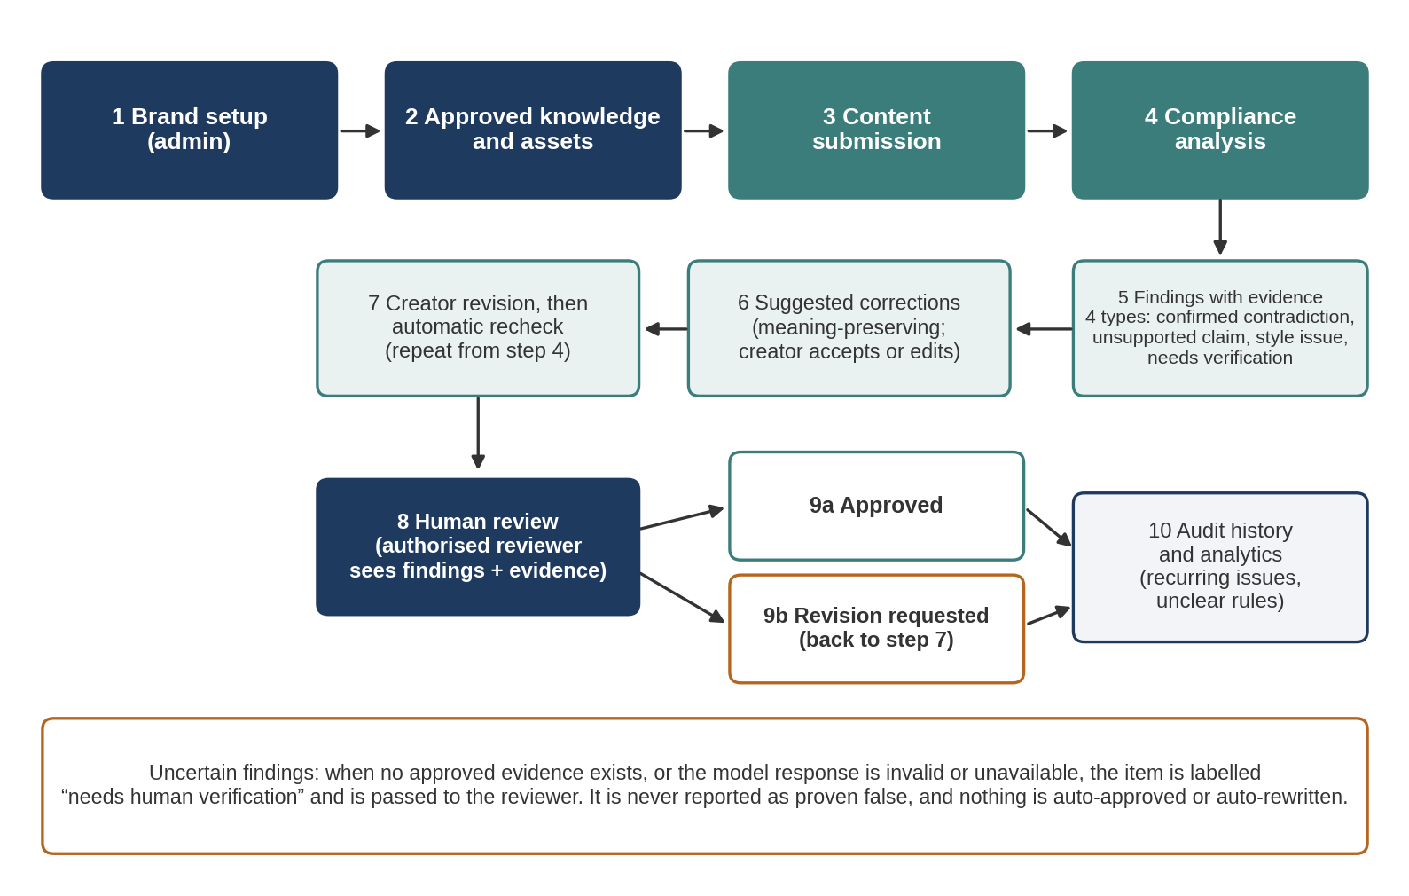
Figure 1. Proposed end-to-end workflow, from brand setup to audit history and analytics, including the handling of uncertain findings.
- Brand setup. An administrator or brand manager creates the workspace and roles.
- Approved knowledge and assets. The knowledge base is filled with terms, prohibited phrases, dated facts, tone rules and asset metadata. Each entry has an identifier and a status (current or retired).
- Content submission. A creator submits text, and the system stores it as version 1.
- Compliance analysis. The rule engine and fact lookup run first. The optional LLM review runs only on the content and the relevant retrieved rules.
- Findings and evidence. Results are merged, deduplicated, validated and stored. Each has one of the four types in Table 5.
- Suggested corrections. The creator receives a minimal-edit suggestion for each finding, or a safe fallback (remove the claim, or use the approved term).
- Creator revision. The creator edits, which creates a new version, and the system rechecks it. This repeats until the creator is ready to submit.
- Human review. An authorised reviewer sees the content, the history, the open and dismissed findings, and the evidence for each.
- Approval or revision request. The reviewer approves, or returns the draft with a comment. The system never approves or publishes by itself.
- Audit history and analytics. Versions, comments and decisions are stored and combined into recurring-issue and guideline-gap summaries.
If no approved evidence is found, if two records conflict, or if the model output fails validation, the item is labelled “needs human verification” and shown to the reviewer. Reviewers can override any finding with a recorded reason. Only a reviewer decision changes a submission to approved.

6.1 Illustrative example
Illustrative only. The company, product, rules and facts below are invented for demonstration. This is not a result from a real customer or a completed experiment.
Sample knowledge base entries: fact AF-014 says “Lumora Smart Lamp is currently sold in India and the United Kingdom only”. Rule TERM-03 prohibits the words “game-changer”, “revolutionary” and “ultimate”. Rule CLAIM-01 says superlatives (“best”, “number one”) need an approved substantiation record. Approved tagline TAG-01 is “light that adapts to your day”.
Submitted caption: “Meet the world’s best smart lamp! Now available across the US. Grab yours today and make the ultimate game-changer part of your home.”
Table 6. Illustrative findings for the sample caption.
ID | Excerpt | Type | Severity | Evidence | Suggested correction | Status
F-1 | “world’s best” | Unsupported claim | High | Rule CLAIM-01. No substantiation record found. | Remove the superlative, or attach approved evidence first. | Needs verification
F-2 | “available across the US” | Confirmed contradiction | Critical | Fact AF-014 (India and UK only). | State the approved regions: “available in India and the UK”. | Open, high priority
F-3 | “ultimate game-changer” | Terminology violation | Medium | Rule TERM-03. | Replace with an approved descriptor, such as tagline TAG-01. | Open
Suggested revision: “Meet the Lumora Smart Lamp: light that adapts to your day. Available now in India and the UK.” In this example the creator accepts the revision and the system rechecks it. No open findings remain. The submission goes to the reviewer with the version history and the three resolved findings, and the reviewer approves it. Had the team wanted to keep “best”, the reviewer could instead have asked for a substantiation record to be added to the knowledge base. The final status is “Approved”, set by the reviewer.

7. Feature Prioritisation and Product Scope
We use a MoSCoW framework. Our rule is to deliver one reliable end-to-end path (submit, analyse, explain, revise, review, record) before adding breadth. A demonstration that works from submission to recorded approval is more useful than many partial features. Also, six hours with two people leaves no room to finish more than that.
Table 7. MoSCoW scope. Only the Must-have tier is committed for the six-hour MVP.
Tier | Features | Notes
Must have (six-hour MVP) | A small configurable knowledge base (terms, prohibited phrases, dated facts, tone rules). Text submission. Deterministic checks for exact terminology and known factual mismatches. AI-assisted contextual review, only if an accessible free service exists. Findings with explanations and evidence references. Suggested corrections or safe fallbacks. Rechecking of revised content. Persistent submission and review status. Basic human approval and revision requests. Basic error handling. | This is the core of the demonstration. It works with the model switched off.
Should have | A simple dashboard. A revision history view. Reviewer comments. A basic recurring-issue summary. A limited number of image or document checks (for example, alt-text presence). | Attempted only after the Must-have path passes testing.
Could have or future | Logo similarity detection. Extensive PDF and DOCX ingestion. Publishing-platform integrations. Multi-tenant enterprise features. Advanced guideline-ambiguity analysis. Sophisticated visual-accessibility analysis. | Not promised for the six-hour build. See the roadmap (Section 15).
A per-feature matrix with value, effort and dependencies is in Appendix D. We do not imply that optional features will be completed within six hours.

8. Technical Architecture and Technology Stack
The architecture below is the planned design. Nothing in it has been implemented or tested. It is a single web application with one back-end service and one embedded database. That fits a two-person, six-hour build and avoids microservices and paid infrastructure.
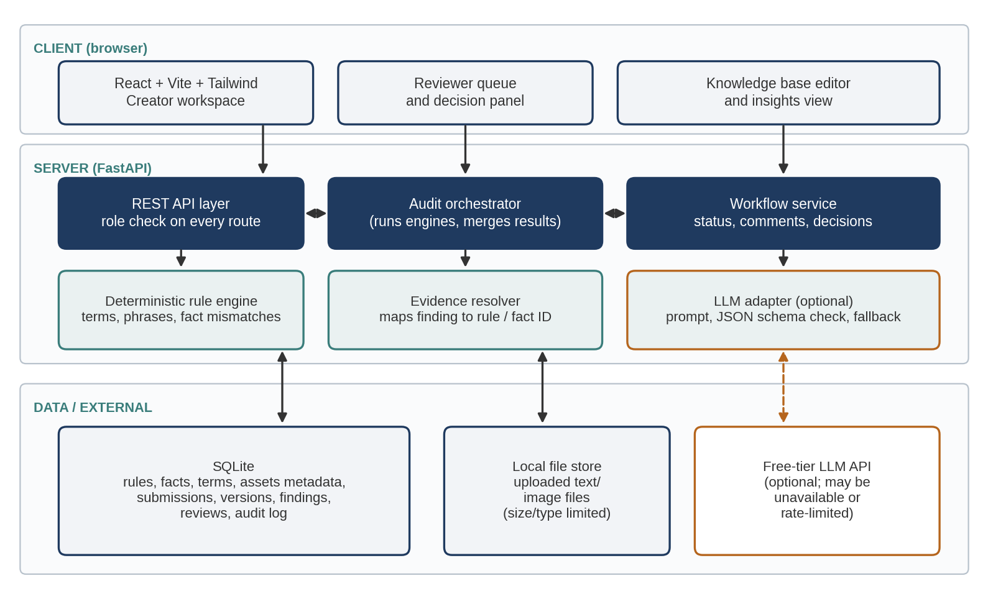
Figure 2. Planned system architecture. The dashed orange path (LLM adapter and free-tier API) is optional.
Data flow: the browser calls a REST endpoint. The API layer checks the caller’s role, then the audit orchestrator runs the deterministic rule engine against the knowledge base. If the LLM adapter is enabled and reachable, it receives only the content and a small set of relevant rules and facts, and returns JSON. The orchestrator validates that JSON, merges it with the rule results, resolves each finding’s evidence ID to a stored record, and saves the findings. The workflow service handles status changes, comments and decisions.
Table 8. Technology decisions and trade-offs.
Layer | Choice | Reason | Trade-off or alternative
Front end | React, Vite, Tailwind CSS [16] | Fast setup and hot reload. The component model suits the creator and reviewer views. Tailwind gives consistent styling quickly. | Plain HTML would be quicker to start but slower to extend.
Back end | Python, FastAPI [13], Pydantic [14] | Typed request and response models, automatic API documentation, and easy use of Python text-processing libraries. Pydantic validates model output. | Less suited to heavy concurrency than other stacks, which does not matter at this scale.
Database | SQLite [15] | Zero setup, a single file, adequate for one local demonstration instance. | Limited concurrent writes. PostgreSQL is the planned upgrade.
Semantic retrieval (optional, future) | PostgreSQL with pgvector [17] | Embedding search once the knowledge base is too large for keyword or full-context retrieval [9]. | Added operational complexity. Not required for the MVP.
LLM (optional) | A free-tier hosted model, for example through the Gemini API [11][12] | Gives contextual review without paid access, if the free tier is available when we build. | Limits vary by model and are not guaranteed [11]. Free-tier data terms differ from paid terms [12]. A local open-weight model is an alternative if hardware allows.
Rule engine | Python, normalised string and pattern matching | Deterministic, explainable, testable, and independent of any external service. | Misses paraphrased violations. This is the gap the optional model review tries to cover.
We will check the free-tier availability, limits and terms of whichever model service we select on the day of the build, because they can change [11][12]. The core workflow must work with the model switched off.

9. Compliance Engine and AI Methodology

9.1 Pipeline
- Normalise the submitted text (case, whitespace, quotation marks) and keep character offsets for highlighting.
- Apply deterministic rules. Match prohibited phrases, enforce preferred terms, and flag superlatives and absolute words that need substantiation.
- Look up approved facts. Extract checkable statements (for example, region or price mentions) and compare them with current fact records.
- Retrieve context. Select the small set of rules and facts relevant to the text. In the MVP this is tag or keyword matching.
- Run the optional LLM review. Ask a model to flag tone, messaging and claim issues that exact matching misses, using only the retrieved material.
- Validate and attribute evidence. Parse the model output against a schema. Keep a finding only if it cites an evidence ID that exists in the supplied context.
- Send every uncertain or disputed item to human review.

9.2 Finding structure
Table 9. Structure of a finding.
Field | Meaning | Example (illustrative)
issue_id | Unique identifier within the submission version. | F-2
category | Terminology, factual, claim, tone, accessibility or visual. | factual
severity | Critical, high, medium or low, set by rule configuration. | critical
excerpt | The problematic text and its character offsets. | “available across the US” (offsets 38 to 62)
explanation | Plain-language reason for the flag. | Approved availability record lists India and the UK only.
evidence | Rule or fact identifier, with version or date. | AF-014
suggested_correction | Minimal-edit option, or a safe fallback. | “available in India and the UK”
verification_status | confirmed_contradiction, unsupported_claim, style_issue or needs_human_verification. | confirmed_contradiction
source_engine | Whether the finding came from rules or the model. | rules

9.3 Role of retrieval and embeddings
Retrieval-augmented generation grounds a model’s output in retrieved documents, so the model does not rely only on what it learned in training [9]. For a knowledge base of tens or low hundreds of entries, tag matching or passing the relevant entries directly in the prompt is enough. RAG, embeddings and a vector database are therefore optional enhancements and are not MVP dependencies. We would add semantic retrieval, possibly with pgvector [17], when the guideline corpus outgrows that approach.

9.4 What the model is and is not trusted to do
The model is a second reviewer. It is not an authority. Its output must be valid JSON against the schema, must cite a supplied evidence ID, and is labelled as model-generated. We will not display a numeric “confidence” score, because a number produced by a language model has not been shown to be calibrated. The interface will use categorical statuses instead. We do not claim that the model is reliable. Unsupported promotional claims are flagged for verification and are never automatically declared false.
Table 10. Known failure modes and planned mitigations.
Risk | Why it matters | Planned mitigation
Hallucinated findings | Language models can produce text that is not grounded in their inputs [6]. | Require a valid evidence ID. Drop or downgrade findings without one. Show the evidence beside every finding.
Prompt injection through submitted or uploaded text | Instructions hidden in content can alter model behaviour. OWASP ranks prompt injection first among LLM application risks, and indirect injection through external content is documented [7][8]. | Treat content as data, delimited in the prompt. Give the model no tools or write access. Validate output. Keep deterministic checks independent of the model. Reviewers see the raw text.
Outdated facts | A stale record can cause a false contradiction. | Facts carry a status and review date. The finding shows the record date. Reviewers can mark a record outdated.
Ambiguous guidelines | Two reasonable readings of a rule produce inconsistent findings. | Record disputes and overrides. Surface frequently disputed rules as guideline-gap insights.
Model unavailable or rate-limited | Free tiers have limits that are not guaranteed [11]. | Automatic fallback to rules only. The interface states that model review did not run.
False positives | Over-flagging erodes trust. | Allow dismissal with a reason. Track dismissal rates per rule. Measure precision on a labelled set (Section 13).

10. Data Sources, Integrations and Dependencies
Table 11. Initial data sources.
Source | Content | Provided by | Use in the platform
Brand guidelines | Tone rules, style rules, do and don’t lists. | Organisation | Rules and tone checks.
Approved facts and product information | Dated statements (availability, features, claims with substantiation). | Organisation | Fact lookup and claim checks.
Terminology and prohibited phrases | Preferred terms, banned words, mappings. | Organisation | Deterministic checks and suggestions.
Official brand assets | Asset names, usage notes, required alt text (metadata in the MVP). | Organisation | Limited asset checks if time permits.
Submitted content | Draft text, later images or documents. | Creators and agencies | The material under review.
Evidence attribution: every rule and fact has a unique ID, a status and a last-reviewed date. Deterministic findings carry the ID of the rule or fact that matched. Model findings are accepted only if they cite an ID that was in the context they were given. The interface resolves that ID to the stored record, so reviewers see the real source text and not a model’s paraphrase.
Table 12. External services and libraries.
Component | Intended use | Status
FastAPI, Pydantic, SQLite [13][14][15] | API, schema validation, storage. | MVP
React, Vite, Tailwind CSS [16] | User interface. | MVP
Free-tier LLM API, for example Gemini [11][12] | Contextual review of tone, messaging and claims. | Optional. The system works without it.
Python text libraries (standard library, regular expressions) | Normalisation and pattern matching. | MVP
PostgreSQL with pgvector [17] | Semantic retrieval. | Future
Publishing, DAM and document integrations | Pull content in and push approved content out. | Future. Not an MVP dependency.
Table 13. Dependency and failure handling.
Failure | System behaviour | What the user sees
Model API unavailable | Skip model review. Run rules only. Log the event without content. | “AI review did not run. Rule-based results only.”
Rate limit exceeded | Retry once with a short back-off. Then fall back to rules only. | Same notice, with the reason.
No relevant approved evidence found | Do not call the claim false. Create a “needs human verification” item. | A flagged item for the reviewer.
Malformed model response | Discard output that fails schema validation. Keep rule findings. | A notice that model output was discarded.
Unsupported file format | Reject at upload by extension and type. Do not parse. | A message naming the supported formats.
Database write failure | Roll back the transaction. Keep the draft in the browser. Return an error. | “Could not save. Your text is preserved. Try again.”

11. Responsible Design, Privacy and Security
The problem statement requires the product to balance automation with human control, protect confidential brand materials, and disclose AI and external service use [1]. We use the NIST AI Risk Management Framework [10] as a checklist for these concerns. It is a reference for our own thinking, and we do not claim conformity with it. We also do not claim legal compliance, certification or complete security.
Table 14. Planned controls. The Stage column shows what the team will attempt in six hours.
Area | Planned control | Stage
Data minimisation | Store only the draft text, user ID, role and decisions. No personal data beyond a name and a role. | MVP
Role-based access | Creator, reviewer, brand manager and admin roles. Every API route checks the role on the server side. The UI hides options but does not enforce access. | MVP (simple seeded users)
Organisation isolation | Organisation ID on every record, filtered on every query, if multi-tenancy is implemented. | Future
File handling | Allow-list of types, size limit, no execution, stored outside the web root, content treated as untrusted. | MVP (text, simple files)
Credentials | API keys in environment variables, never in the repository or the browser. | MVP
Transport | HTTPS in any deployment. | Deployment
Logging | Log events, IDs and error codes only. Do not log submitted content or model prompts. | MVP
Retention and deletion | Configurable retention. An admin can delete a submission and its versions. | Planned
Third-party AI disclosure | A visible notice when the model review is used. The documentation distinguishes paid and free tiers, including whether prompts are used to improve the provider’s products [12]. We therefore plan to use only non-confidential sample data with any free-tier model, and offer a rules-only mode. | MVP
Human override | Reviewers can approve or reject regardless of findings. Overrides require a reason, and the record shows who decided and when. | MVP
Prompt injection | Content passed as delimited data. No tools or actions available to the model. Output is schema-validated [7][8]. | MVP
Accessibility of the product | We aim for WCAG 2.2 AA as a design target for our own interface [5], including text alternatives, sufficient contrast and keyboard operation. We will not claim conformance without testing. | Target
Misleading-claim prevention | Unsupported claims are flagged for verification. Suggestions never invent facts, and use only approved wording. | MVP
Limits of AI analysis | Findings are decision support. They are not a legal or compliance determination. | Stated in the UI

Integrity and disclosure
The official rules require disclosure of significant AI assistance, reused material, templates and external services [1]. This proposal was drafted with AI assistance (Claude, Anthropic), and the team is responsible for reviewing and confirming its content before submission. Any template, boilerplate or AI-generated code used in the build will be listed in the Round 2 submission. This proposal is a plan. No product code has been written for it, and development will start inside the official build window.

12. Six-Hour Development Plan and Team Allocation
The allocation below is a proposal for the team to confirm. It is not evidence of completed work. One member leads front end and integration. The other leads back end, database and audit logic. The two can swap if preferred.
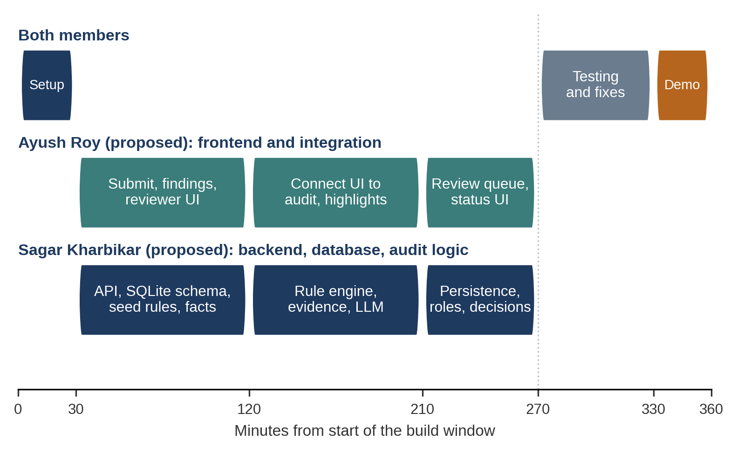
Figure 3. Proposed six-hour execution timeline with responsibilities by team member.
Table 15. Milestones and exit criteria.
Minutes | Milestone | Done when
0 to 30 | Scope, repository, API contract (both) | Repository created. API contract and finding schema agreed. Sample rules and facts drafted. Responsibilities confirmed.
30 to 120 | Parallel front end and back end | UI can submit text and render a mock findings list. The API stores submissions, versions and the knowledge base in SQLite.
120 to 210 | Audit engine and integration | Rule engine returns real findings with evidence IDs. UI shows highlighted excerpts. LLM adapter works or is disabled with fallback.
210 to 270 | Review workflow and persistence | Submit for review, approve or request revision, comments, version history and role checks work end to end.
270 to 330 | Testing and integration fixes | Labelled test set is run. Failures are triaged, and critical bugs are fixed. Error handling is checked.
330 to 360 | Final demonstration preparation | Demo script is rehearsed on a clean database. Known limitations are listed. Screenshots or a recording are prepared.
Ayush Roy (proposed) takes the React and Tailwind UI, the creator workspace, the reviewer queue and decision panel, API integration, and front-end error states, LLM adapter and fallback, and role checks.
Sagar Kharbikar (proposed) takes the FastAPI endpoints, SQLite schema, rule engine, fact lookup, evidence resolver.
Both of us share the API contract, test-set creation and labelling, bug triage, the demonstration script, and the written explanation of each member’s contribution that the organiser requires later [1].
Table 16. Contingency plans.
Situation | Response
AI service unavailable or limits too low | Ship with the deterministic engine only. The model adapter stays behind a switch. The demonstration shows the fallback message.
Front-end and back-end integration fails | Fall back to the agreed contract with mock responses, then fix the routes one at a time. Keep a minimal HTML form as a last resort.
Time overrun | Cut Should-have items first, then reduce the knowledge base scope. Never cut persistence, human approval or the evidence display.

13. Testing and Evaluation Plan
We will build a small labelled test set of invented sample content, with about 40 to 60 short items covering each scenario in Table 17. Both members will label expected findings independently, then resolve disagreements before running the system. The same team writes the rules and the test items, so results will be optimistic. We will say so in any report and will not present them as general performance.
Table 17. Test scenarios.
ID | Scenario | Expected behaviour | How measured
T1 | Clean content | No findings. | False-positive count.
T2 | Prohibited terminology | Terminology finding with the rule ID and a suggestion. | Match against labels.
T3 | Claim contradicted by an approved fact | Confirmed contradiction citing the fact ID. | Correct type and evidence ID.
T4 | Claim with no supporting evidence | Unsupported claim, flagged for verification, not called false. | Correct type and status.
T5 | Tone inconsistency | Style finding (rules or model). | Match against labels. Reported separately.
T6 | Revised content after corrections | Findings cleared on recheck. New version saved. | Re-run result and version count.
T7 | Reviewer approval and revision request | Correct status change, comment and audit entry. | Workflow test.
T8 | Invalid input and API failure | Clear error. Rules-only fallback. No data loss. | Failure-injection test.
Table 18. Metrics. Targets are goals, not achieved results.
Metric | Definition | Measured by | Target (not a result)
Precision | Correct findings ÷ all findings, per category. | Compare with labels. | At least 0.80 on deterministic categories.
Recall | Labelled issues found ÷ all labelled issues. | Compare with labels. | At least 0.80 on deterministic categories.
Evidence attribution correctness | Findings citing the correct rule or fact ID. | Manual check of each finding. | All deterministic findings.
Correction acceptance | Suggestions accepted or edited ÷ shown. | MVP feedback sessions. | Reported only. No target set.
Workflow completion | Runs from submission to recorded decision. | Scripted end-to-end runs. | Three of three rehearsal runs.
Latency and failure rate | Time per audit, and failed requests. | Timing in test runs. | Rules-only audit in about one second. Model audit time reported.

14. Expected Impact and Success Criteria
The benefits below are hypotheses about what BrandGuard AI could change. None has been demonstrated. Each is tied to an indicator and an evaluation method so that it can be confirmed or rejected.
Table 19. Expected benefits, indicators and evaluation.
Expected benefit | Indicator | Evaluation method
Earlier identification of brand violations | Share of seeded violations caught before the reviewer step. | Labelled test set. Task sessions.
More consistent content | Number of terminology and tone findings per submission across versions. | Version history on sample content.
Faster identification of unsupported claims | Time to reach each flagged claim, compared with a manual read. | Timed task with and without the tool.
Less repetitive manual checking | Reviewer-reported effort and number of review rounds. | Feedback sessions.
Visibility of recurring problems | Can the brand manager name the most frequent rules and the most disputed rules from the summary? | Task in the feedback session.
Clearer accountability | Percentage of decisions with a reviewer, time and reason on record. | Audit-log inspection.
These claims must be validated through testing and user feedback before they are presented as results.

15. Limitations, Risks and Future Roadmap
A six-hour prototype has hard limits. The knowledge base will be small and written by the team, so results will not generalise to real guideline documents, which are often inconsistent or ambiguous. Free-tier model access can be limited or change without notice [11], and models can produce unsupported output [6]. Visual analysis is the hardest category to automate reliably, and most of it is deferred. Finally, until the interviews and feedback sessions in Section 4 are done, there is no real-world user validation, and the personas and workflow are assumptions.
Table 20. Roadmap.
Phase | Scope
MVP (six-hour build) | Text review against a small knowledge base, deterministic checks, optional model review, evidence-linked findings, revision rechecking, human approval, persistent records.
Next iteration | PDF and DOCX ingestion, richer audit history, reviewer comment threads, stronger recurring-issue analytics, guideline-gap views, basic image alt-text checks.
Later iterations | Visual consistency checks (logo and colour use), semantic retrieval, publishing integrations, multi-tenant enterprise controls, formal security review.

16. Conclusion
BrandGuard AI responds to the Inkloom AI problem statement with a bounded, buildable design. Deterministic rules and approved facts produce findings that point to a specific source. An optional model adds contextual coverage, but its output is validated and labelled, and we never trust it alone. Corrections are suggested and never imposed. An authorised reviewer makes every approval decision, and each decision is recorded. The plan is feasible for two people in six hours because it commits first to one reliable end-to-end path and works without paid services. Whether it delivers the benefits we expect is for the testing and user feedback in this proposal to show.

References
Numbers match the citations in the text. Access dates are given for sources opened during preparation (25 October 2026). Sources [5], [8], [9], [10] and [13] to [17] are cited by their canonical URL or DOI. The team should re-open them before final submission.
[1] Inkloom AI. Problem Statement by Inkloom AI (including Round 1 to 3 submission requirements, judging criteria and general rules). Official event document supplied to participants as “Problem_statement.pdf”. No public URL was provided.
[2] U.S. Federal Trade Commission. FTC Policy Statement Regarding Advertising Substantiation (appended to Thompson Medical Co., 104 F.T.C. 648, 1984). https://www.ftc.gov/sites/default/files/attachments/training-materials/policy_substantiation.pdf (accessed 25 October 2026).
[3] Advertising Standards Council of India (ASCI). The Code for Self-Regulation of Advertising Content in India. https://www.ascionline.in/wp-content/uploads/2023/07/Code-Book.pdf ; overview at https://www.ascionline.in/the-asci-code (accessed 25 October 2026).
[4] WebAIM. The WebAIM Million: The 2025 report on the accessibility of the top 1,000,000 home pages. https://webaim.org/projects/million/2025 (accessed 25 October 2026).
[5] W3C. Web Content Accessibility Guidelines (WCAG) 2.2, W3C Recommendation, October 2023. https://www.w3.org/TR/WCAG22/ (canonical URL; criteria 1.1.1 and 1.4.3 confirmed through secondary descriptions on 25 October 2026).
[6] Ji, Z., Lee, N., Frieske, R., Yu, T., Su, D., Xu, Y., Ishii, E., Bang, Y. J., Madotto, A., and Fung, P. “Survey of Hallucination in Natural Language Generation.” ACM Computing Surveys, 55(12), 2023. https://doi.org/10.1145/3571730 ; preprint https://arxiv.org/abs/2202.03629 (accessed 25 October 2026).
[7] OWASP GenAI Security Project. LLM01:2025 Prompt Injection, OWASP Top 10 for LLM Applications. https://genai.owasp.org/llmrisk/llm01-prompt-injection/ (accessed 25 October 2026).
[8] Greshake, K., Abdelnabi, S., Mishra, S., Endres, C., Holz, T., and Fritz, M. “Not what you’ve signed up for: Compromising Real-World LLM-Integrated Applications with Indirect Prompt Injection.” AISec ’23, 2023. https://arxiv.org/abs/2302.12173
[9] Lewis, P., Perez, E., Piktus, A., et al. “Retrieval-Augmented Generation for Knowledge-Intensive NLP Tasks.” NeurIPS 2020. https://arxiv.org/abs/2005.11401
[10] National Institute of Standards and Technology. Artificial Intelligence Risk Management Framework (AI RMF 1.0), NIST AI 100-1, January 2023. https://doi.org/10.6028/NIST.AI.100-1
[11] Google. Gemini API: Rate limits. https://ai.google.dev/gemini-api/docs/rate-limits (accessed 25 October 2026).
[12] Google. Gemini API: Billing and free/paid tiers. https://ai.google.dev/gemini-api/docs/billing (accessed 25 October 2026).
[13] FastAPI documentation. https://fastapi.tiangolo.com/
[14] Pydantic documentation. https://docs.pydantic.dev/latest/
[15] SQLite documentation. https://www.sqlite.org/docs.html
[16] React documentation. https://react.dev/ ; Vite documentation, https://vite.dev/guide/ ; Tailwind CSS documentation, https://tailwindcss.com/docs
[17] pgvector: open-source vector similarity search for PostgreSQL. https://github.com/pgvector/pgvector

Appendix A. Sample Data Schema and API Contract
This is a compact proposal, and it may change in the first 30 minutes of the build.
Table 21. Proposed database tables.
Table | Main fields
users | id, name, role (creator, reviewer, brand_manager, admin)
rules | id, type (term, phrase, claim, tone), pattern, severity, message, suggestion, status
facts | id, topic, statement, structured_value, valid_from, last_reviewed, status
assets | id, name, usage_note, required_alt_text
submissions | id, title, content_type, author_id, status (draft, in_review, approved, revision_requested)
versions | id, submission_id, number, body, created_at
findings | id, version_id, category, severity, start, end, explanation, evidence_id, suggestion, verification_status, source_engine, resolution (open, accepted, edited, dismissed)
reviews | id, submission_id, reviewer_id, decision, comment, created_at
audit_log | id, actor_id, action, object_id, created_at (no content stored)
Table 22. Proposed endpoints.
Endpoint | Purpose and roles
POST /api/submissions | Create a submission with a title, body and content type. Returns the ID and version 1. Creator.
POST /api/submissions/{id}/audit | Run the audit on the latest version. Returns findings and which engines ran. Creator.
POST /api/submissions/{id}/versions | Save a revised body, then re-audit. Creator.
PATCH /api/findings/{id} | Mark a finding accepted, edited or dismissed, with a reason. Creator.
POST /api/submissions/{id}/submit | Send for review. Creator.
POST /api/submissions/{id}/decision | Approve or request revision, with a comment. Reviewer, brand manager.
GET /api/submissions/{id} | Submission, versions, findings, reviews. Role-limited.
GET/PUT /api/knowledge/{rules|facts} | Read or edit the knowledge base. Brand manager, admin.
GET /api/insights/recurring | Counts by rule, dismissal and override rates. Manager, brand manager.

Appendix B. Sample Brand Rules and Sample Audit Response
This is invented data for the Lumora Home scenario (Section 6.1). It is not a real customer.
// knowledge base (excerpt)
{"id":"AF-014","type":"fact","topic":"availability",
"statement":"Lumora Smart Lamp is currently sold in India and the United Kingdom only",
"structured_value":{"regions":["IN","GB"]},"status":"current"}
{"id":"TERM-03","type":"phrase","pattern":["game-changer","revolutionary","ultimate"],
"severity":"medium","suggestion":"Use an approved descriptor such as TAG-01"}
{"id":"CLAIM-01","type":"claim","pattern":["best","number one","#1"],
"severity":"high","message":"Superlatives need an approved substantiation record"}

// POST /api/submissions/17/audit -> 200 (illustrative response)
{"submission_id":17,"version":1,
"engines":{"rules":"ran","llm":"unavailable"},
"findings":[
{"issue_id":"F-1","category":"claim","severity":"high",
"excerpt":{"text":"world's best","start":11,"end":23},
"explanation":"Superlative with no approved substantiation on file.",
"evidence":{"id":"CLAIM-01","kind":"rule"},
"suggested_correction":"Remove the superlative, or attach approved evidence.",
"verification_status":"unsupported_claim","source_engine":"rules"},
{"issue_id":"F-2","category":"factual","severity":"critical",
"excerpt":{"text":"available across the US","start":38,"end":61},
"explanation":"Approved record lists India and the UK only.",
"evidence":{"id":"AF-014","kind":"fact"},
"suggested_correction":"available in India and the UK",
"verification_status":"confirmed_contradiction","source_engine":"rules"}]}

Appendix C. Interview Questionnaire
The interviews are semi-structured and last about 30 minutes. Participants are told the purpose, that taking part is voluntary, and that we do not need confidential material.
- Please describe your role and the kind of content you create, review or approve.
- Walk me through the last piece of content you published, from first draft to approval.
- Who checks the content, and what do they check it against?
- Where do you find approved terms, facts and claims? How current are they?
- Tell me about a time something went out with an error. How was it found, and how long did it take?
- How do you handle claims such as “best” or “fastest”? Who decides if they can be used?
- Have you had a guideline that people read in different ways? What happened?
- If a tool suggested a correction, what would make you trust or distrust it?
- What material would you never upload to an external AI service?
- Is there anything we should have asked and did not?

Appendix D. Feature Prioritisation Matrix
Table 23. Features by tier, value, effort and dependency (estimates by the team, not measurements).
Feature | Tier | Value | Effort | Depends on
Knowledge base (terms, facts, rules) | Must | High | M | Schema, seed data
Text submission and versions | Must | High | S | API, database
Deterministic term and fact checks | Must | High | M | Knowledge base
Findings with evidence references | Must | High | M | Rule engine, evidence resolver
Suggested corrections and fallbacks | Must | High | S | Rule messages
Recheck on revision | Must | High | S | Versions, engine
Reviewer approve or revise, persistent status | Must | High | M | Roles, workflow service
Optional LLM review with fallback | Must (if free access) | Medium | M | Free API, schema validation
Dashboard and recurring-issue summary | Should | Medium | M | Stored findings
Reviewer comments and history view | Should | Medium | S | Reviews table
Image alt-text or simple document checks | Should | Medium | M | File handling
Logo similarity, full visual accessibility | Could | Medium | L | Image analysis
PDF and DOCX ingestion, integrations, multi-tenancy | Could | Medium | L | Parsers, deployment

Appendix E. Risk Register
Table 24. Main project and product risks.
Risk | Impact | Mitigation | Owner (proposed)
Free model tier unavailable or limited | Medium | Rules-only fallback. Demo works without the model. | Sagar Kharbikar
Scope grows beyond six hours | High | Fixed Must-have list. Cut Should items first. | Both
Integration problems between UI and API | High | Agree the contract at 0 to 30 minutes. Use mock responses. | Ayush Roy
Test set too small or biased | Medium | State the limit. Label independently. | Both
Prompt injection through content | Medium | Delimited data, no tools, schema validation. | Sagar Kharbikar
False positives reduce trust | Medium | Dismissal reasons, per-rule tracking. | Both
Confidential data sent to external service | High | Sample data only. Rules-only mode. Disclosure. | Both
Assumptions about users wrong | Medium | Interviews and feedback sessions (Section 4). | Both

Appendix F. Alignment with Round 1 Requirements and Judging Criteria
Table 25. Round 1 judging criteria (100 points) mapped to sections [1].
Criterion | Points | Where addressed | Main content
Understanding of the problem statement | 25 | Sections 1, 2, 3, 4; Appendix C | Problem and evidence, users and setting, research plan, validation matrix.
The proposed solution | 25 | Sections 5, 6, 7, 14 | Product concept, finding types, workflow, example, scope, expected impact.
Technical plan | 20 | Sections 8, 9, 10, 11, 13; Appendices A, B | Architecture, engine, data sources, failure handling, security, testing.
Originality of approach | 15 | Sections 5.2, 5.4, 9 | Evidence-backed findings, meaning-preserving corrections, guideline-gap insights, graded uncertainty.
Feasibility and scope | 15 | Sections 7, 12, 15; Appendices D, E | MoSCoW scope, six-hour plan, contingencies, limitations, risks.
Table 26. Official Round 1 submission items mapped to sections [1].
Requirement in the problem statement | Section
Problem definition and evidence | 2
Target users, needs and organisational setting | 3
Research, interviews, observations, surveys or other evidence | 4 (desk research done; primary research planned)
Proposed solution, value proposition, end-to-end workflow | 5, 6
Planned features, technology stack, integrations, data sources | 7, 8, 9, 10
Responsible design: privacy, security, human oversight | 11
Development plan, role allocation, expected impact | 12, 14

Tools and AI disclosure
We used AI tools to help draft and edit this plan. The research, the evidence and the decisions in it are our own. The integrity statement in Section 11 gives the details required by the official rules.

